**Western High School - AICE Diploma Requirements**

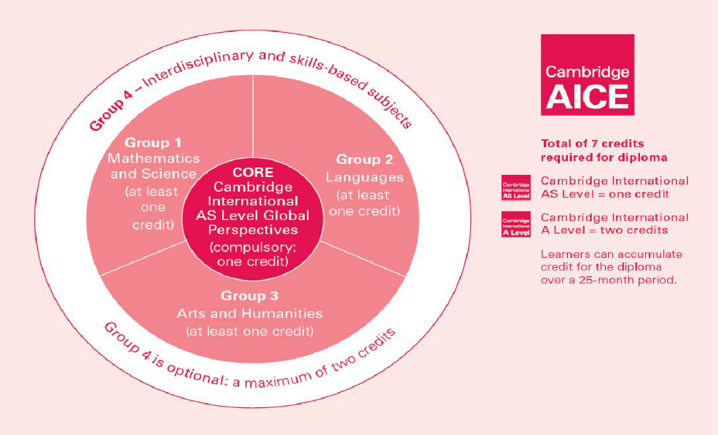

WHS is only offering AS Level (one year = one credit) Courses

Candidates must pass 7 Cambridge Exams among 4 groups of courses.

Western High School offers the following AICE Courses

|  |  |
| --- | --- |
| **Required Course**: | Global Perspectives |

|  |  |  |  |
| --- | --- | --- | --- |
| **Group 1 –**  **Mathematics and Science**  (Choose One) | **Group 2 –**  **Languages**  (Choose One) | **Group 3 –**  **Arts and Humanities**  (Choose One) | **Group 4 –**  **Interdisciplinary and skills-based subjects** |
| * Environmental Management* * Marine Science * Mathematics * Psychology* | * English Language | * U.S. History   **(International 10th & US History 11th)**   * Media Studies * Sociology * Psychology* * Environmental Management* | * English General Paper * Thinking Skills |

**Possible Course Progression for AICE Diploma**

Starting in 9th Grade (PREFERRED)

|  |  |  |  |
| --- | --- | --- | --- |
| **9th** | **10th** | **11th** | **Notes** |
| **AICE General Paper**  **AICE Thinking Skills** | **AICE English Language**  **AICE Global Perspectives** | **Select two courses…**  AICE US History  AICE Environmental Mgmt.*  AICE Psychology*  AICE Marine Science  AICE Media Studies  AICE Sociology  AICE Mathematics (Level 5) | Benefits of starting in 9th   * With 100 service hrs., Bright Futures will be available as soon as they start college   FYI…  Students can take more than 7 courses, in case they want more University Credit and/or a little reassurance just in case they fail an exam. |
|  | **Select one course…**  AICE International History  AICE Environmental Mgmt.*  AICE Psychology*  AICE Marine Science  AICE Media Studies  AICE Sociology  AICE Mathematics (Level 5) |

Starting in 10th Grade

|  |  |  |  |
| --- | --- | --- | --- |
| **Notes** | **10th** | **11th** | **12th** |
| FYI…  Students can take more than 7 courses; in case they want more University Credit and/or a little reassurance just in case they fail an exam.  If they fail an exam their senior year, they cannot come back and retake exam in November. NO AICE DIPLOMA = NO BRIGHT FUTURES  Bright Futures may not be in effect until your second semester in college. | **AICE General Paper**  **AICE Thinking Skills** | **AICE English Language**  **AICE Global Perspectives** | **Select two courses…**  AICE Environmental Mgmt.*  AICE Psychology*  AICE Marine Science  AICE Media Studies  AICE Sociology  AICE Mathematics (Level 5)  AICE World History |
|  | **Select one course…**  AICE US History  AICE Environmental Mgmt.*  AICE Psychology*  AICE Marine Science  AICE Media Studies  AICE Sociology  AICE Mathematics (Level 5) |

Students planning on attending College Academy their junior year

|  |  |  |
| --- | --- | --- |
| **9th** | **10th** | **Notes** |
| **AICE General Paper**  **AICE Thinking Skills**  **AICE Global Perspectives** | **AICE English Language** | Benefits   * Will be able to earn AICE Diploma before they move on to the College Academy * With 100 service hrs., Bright Futures will be available as soon as they start college   FYI…  Students can take more than 7 courses; in case they want more University Credit and/or a little reassurance just in case they fail an exam. |
|  | **Select three courses…**  AICE International History  AICE Environmental Mgmt.*  AICE Psychology*  AICE Marine Science  AICE Media Studies  AICE Sociology  AICE Mathematics (Level 5) |

Students choosing to take an AICE Class a-la-carte should know that AICE Classes are

* College level courses
* Should be a Level 4 or 5 on F.A.S.T. ELA or a Level 3 with consistently excellent grades and attendance
* Require a lot of writing and research, no multiple choice
* Are required to take AICE Exam at the end of the school year